Year 7 Visual Arts- Introduction to Aboriginal Art and Symbolism

- Draw or find images of the following symbols
Symbol | Picture | Symbol | Picture
Waterhole | 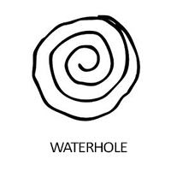 | Campfire
Rainbow |  | Human
Emu |  | People sitting
Star |  | Smoke

- What does dreamtime mean?

- Visit the website link HERE
Find 2 examples of Dream time paintings of your choice. Name the Title and Artist, 2 art elements and any symbols (IF you can identify in the painting). Use the art elements help HERE
One example has been completed below:
Artwork | Title and Artist | 2 Art Element | Any Symbols?
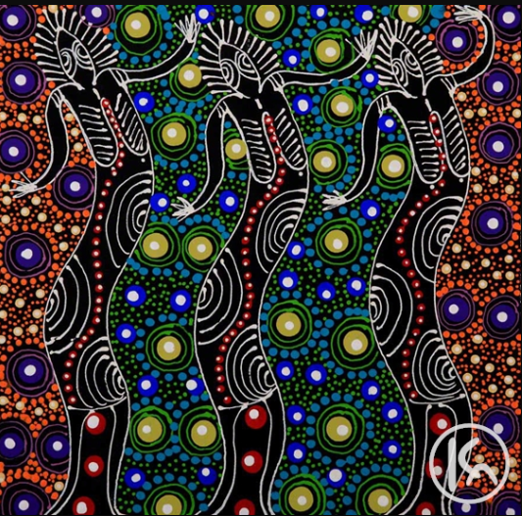 | Title: Dreamtime Sisters  Artist: Colleen Wallace Nungari | Colours- secondary colours such as orange, purple and green  Bright and bold  Line- curved lines  Moving lines  Swirly lines | Campsite symbol  Star symbol (similarity)
1. | Title:  Artist:
2. | Title  Artist:

EXTENSION TASK:
- Watch the video titled: Songlines- Aboriginal Art and Storytelling, and complete the following questions:
https://www.youtube.com/watch?v=zp_vYfEiuGU
Fill in the gaps: (from the video)
- “We understand the _______, the plants, the birds, the ________, the whole structure…”
- “Art documents the __________ of the land”
Answer the questions below:
- What is a Songline? ______________________________________________________________________________________________________________________________________________________
- What helps document the history of Indigenous times? _____________________________
- How is Art a written language? ______________________________________________________________________________________________________________________________________________________

