**Assessment Task 1: Studio Arts Semester 2 Name: _______________**

**Appropriation**

**Within this assessment task you are to complete a theory booklet regarding appropriation and folio a studio process to create your own appropriation of an artwork.**

**This handout includes the steps that take place to create your appropriated artwork.**

**You can appropriate the artwork by:**

* Recreating it in a new medium (clay, collage, painting it in different colours, using pencil or chalk, Photoshop….) Preferably, this assessment should be painted.
* Using the subject matter but painting/ drawing it in your own way (eg my own version of people travelling on a windy day)
* Altering aspects of the subject matter
* Included major themes of the artwork but altering
* Using the style but interpreting it in your own way

Below is a checklist with the guidelines of allocated class time for each section of the assessment. You may need to spend some extra time outside of class to complete the theory booklet or written components.

|  |  |  |
| --- | --- | --- |
| **Week** | **Work to complete** | **Tick when completed** |
| **1 and 2** | Theory Booklet (2 periods) |  |
| Step 1: Select your choice of artwork to appropriate |  |
| **3** | Step 2: Mood Board (2 periods) |  |
| Step 3: Proposal ( 1 period) |  |
| **4** | Step 4A: 2x Sketch designs (2 periods)  Step 4B: Annotate your sketch designs (1 period) |  |
| **5 and 6** | Step 4C: Final Artwork (5 periods) |  |
| Step 5: Evaluation (1 period) |  |

**Step 1: Select an artwork to Appropriate.**

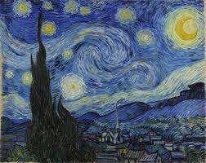

**Starry Night**

**Vincent Van Gogh 1889**

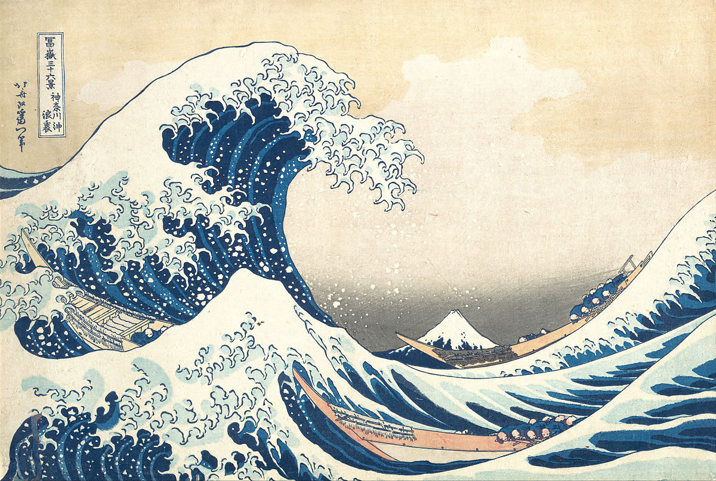

**The Great Wave off Kanagawa**

**Print by Hokusai 1820-1831**

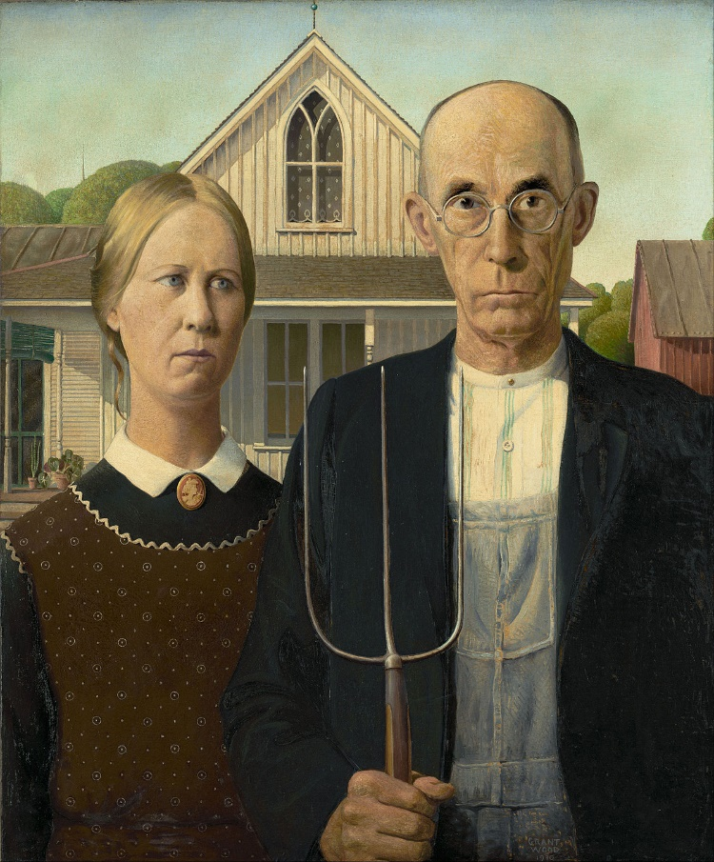

**American Gothic**

**Grant Wood 1930**

**Step 2: Mood Board**

**In preparation of creating an appropriated artwork:**

**What is a mood board?**

A **mood board** is a type of visual presentation or a collage consisting of images, text, and samples of objects in a composition. It can be based upon a set topic or can be any material chosen at random. A **mood board** can be used to convey a general idea or feeling about a particular topic. Mood boards are not only used in school, but in the beginning of concepts in companies, graphics, artistic jobs and the design world.

**What do you need to include?**

Since you will be creating an appropriated artwork…

* An image of the Original Artwork
* Colour Palette ideas
* Features you will include:
* Potential Text and symbols-
* Design inspiration
* Landscape inspiration eg: ocean, hills, city etc
* Medium inspiration- watercolour? Fineliner? Paint?

**Does this need to be completed in my visual diary?**

You can choose to either- complete a digital version of the mood board (Refer to example 1 below) OR print off images and create an annotated/ designed mood board. (Refer to Example 2)

**How big should it be?**

The mood board must be a minimum of one **A3 page** in your visual diary.

If it is a digital version, this must be printed and put into your artbook. Refer to the examples below and on the following pages:

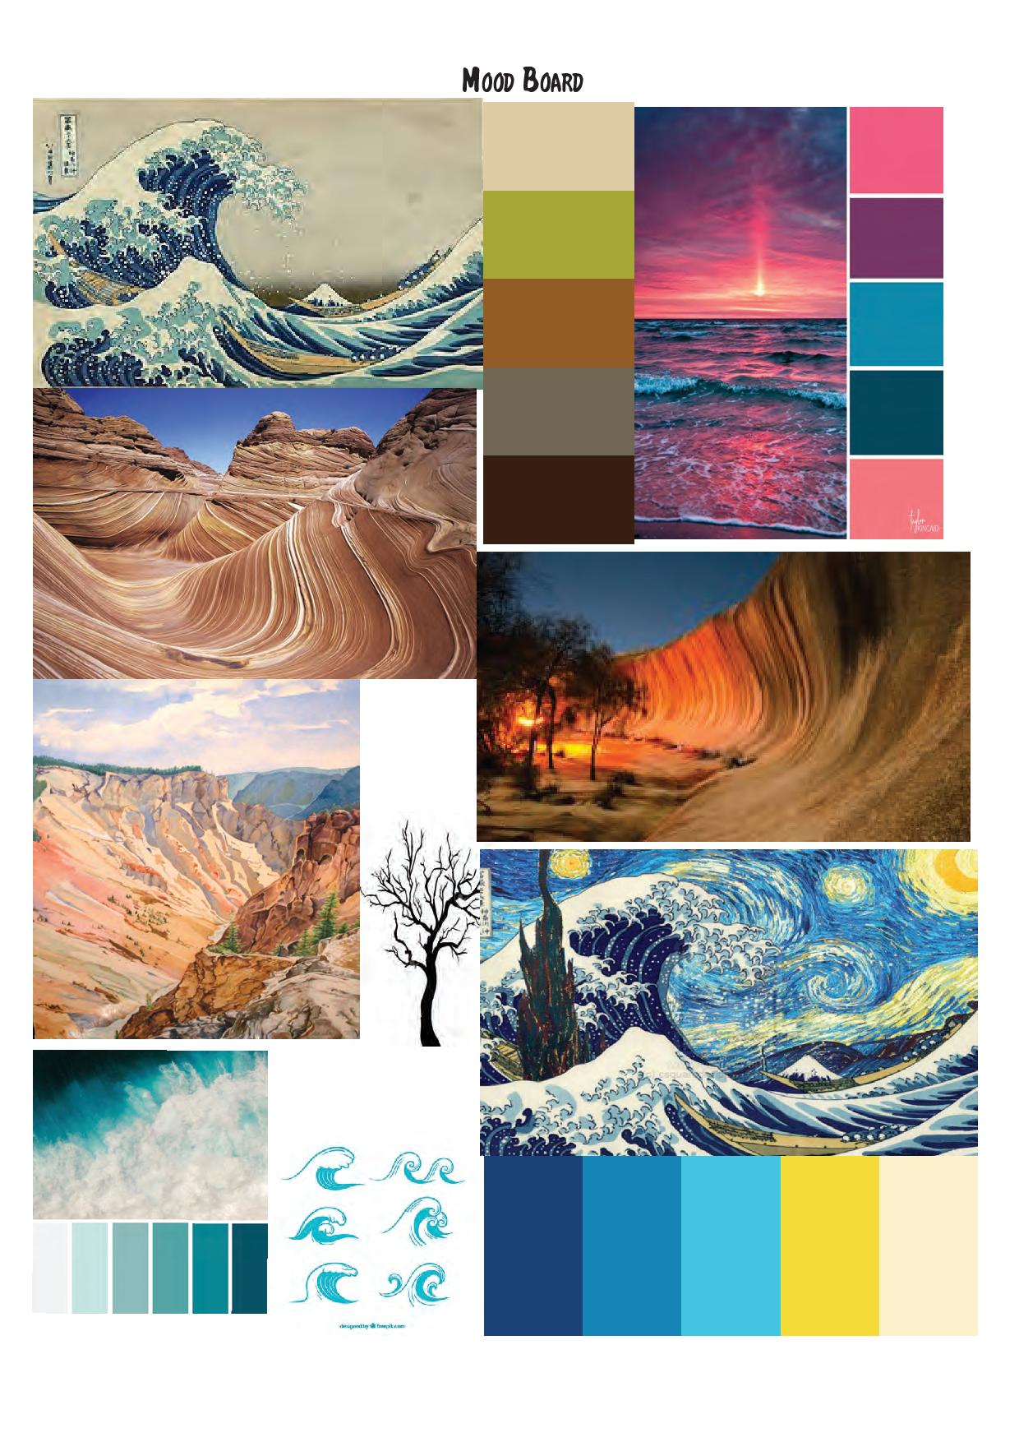

**Example 1: Digital Mood Board**

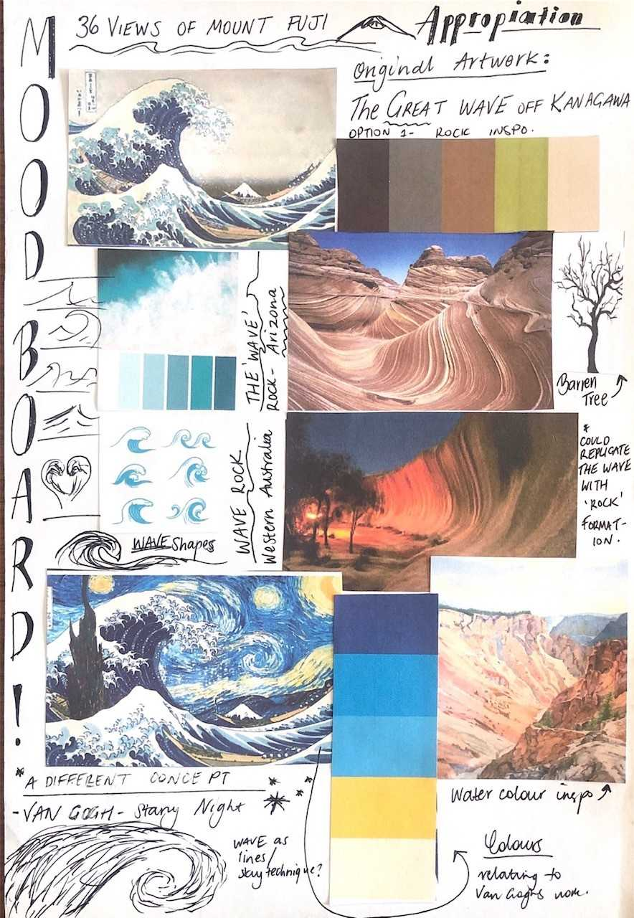

**Example 2: Printed and Annotated Mood Board**

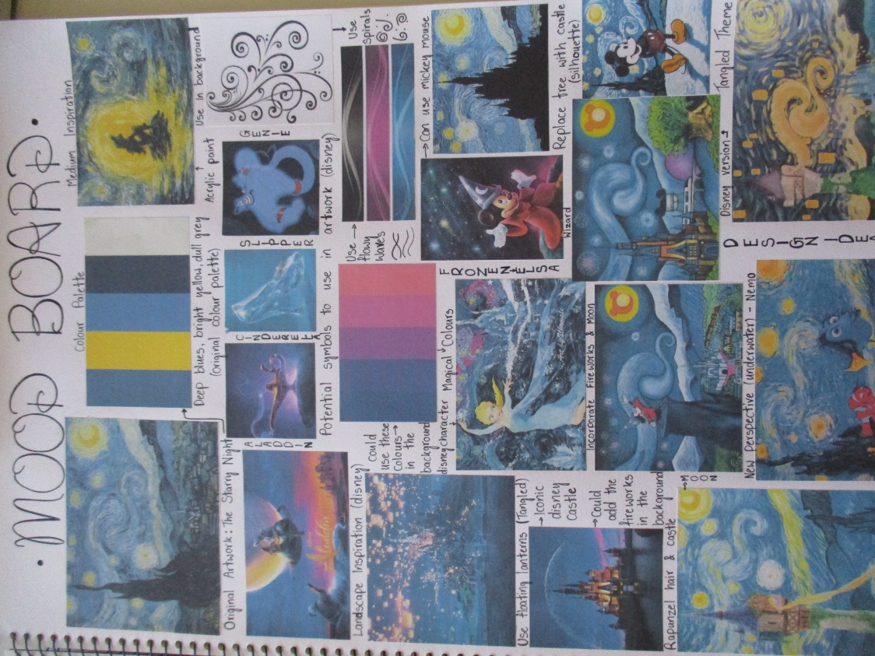

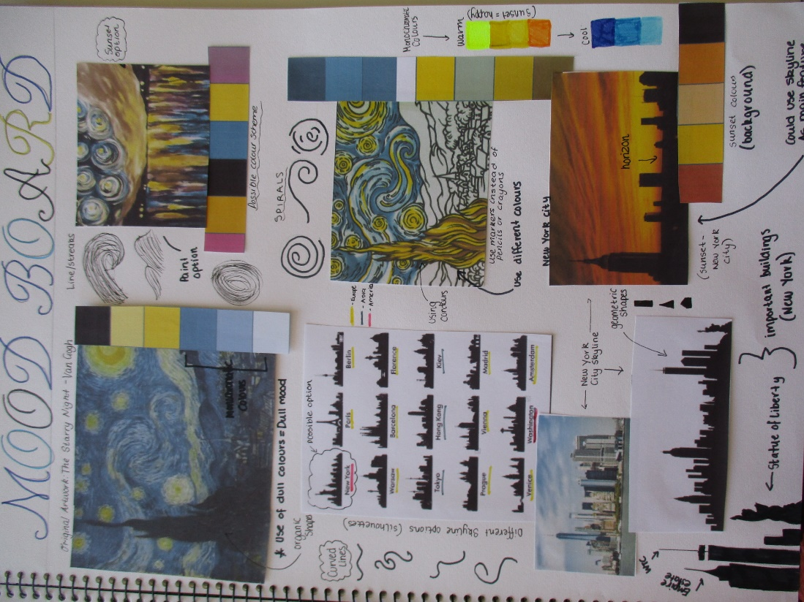

**Step 3: Write a proposal about what you plan to do.**

Answer the below in paragraph format.

* The title of the artwork I have chosen to appropriate:
* What subject matter I plan to change
* Materials and techniques I plan to use
* Two art elements I plan to focus on and a descriptive word for how I plan to use them
* Two art principles I plan to focus on and a descriptive word for how I plan to use them

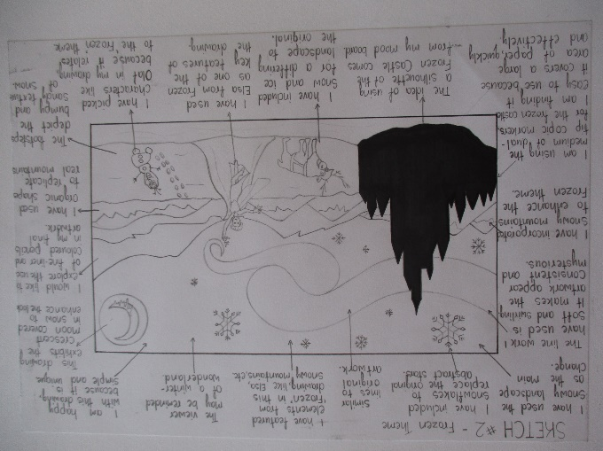

**Step 4: Create your appropriation**

1. **Plan 2x sketch ideas in your visual diary using the mood board and proposal as guidance.**
2. **Annotate each sketch outlining the changes/ similarities comparing to the original artwork**
3. **Create your appropriated artwork**

**Step 5: Evaluation**

Answer the below question in paragraph format.

1. *Did your artwork communicate what you intended? Why or why not?*
2. *Discuss which art elements and principles have been used in your artwork. (Glossary provided below)*
3. Table

   Description automatically generated*What materials and techniques and processes were followed to create your final piece?*
4. *How is your appropriated artwork different to the original artwork? How is it similar?*