HOW TO ANNOTATE INSPIRATIONAL ARTWORKS

Identify
Underneath the artwork you have pasted in your visual diary, write the artist’s name, title of artwork (include the date and materials if you have this information)
Describe and explain
Describe the art elements that are seen in the artwork (E.G – Vibrant colour)
Identify the art principles that the described elements create.
What materials is the artwork made of? (E.g acrylic paint, oil paint, pastel, charcoal)
What techniques has the artist used? (E.g, crosshatching, blending)
Interpret
What ideas or meanings do you think the artwork holds (what story is the artwork trying to tell?)
What aesthetic qualities are seen in the artwork (the mood, or feeling, that the art elements and principles create. E.G – The vibrant colours create a feeling of happiness.)
What has influenced you to choose this particular artwork?– is it the subject matter? Materials? Art elements or principles?

You may also choose to visually annotate the artwork, this is when you draw out / recreate certain aspects of the artwork that has inspired you to include it in your folio.

ANNOTATION SENTENCE STARTERS FOR INSPRITAIONAL ARTWORKS

- The artist has used ____________ tones and ____________ texture, the elements create a ___________ mood.
- The_________ colour and _____________line create the principle of _____________in the artwork.
- Use of crosshatching with a 4b ______________ creates a rough texture
- The paint has been blended using a ‘wet on wet’ technique
- The artist has used a palette knife
- Proportion is created through the use of ________ forms
- The meaning of this artwork could be________________, this can be seen through______________
- I aim to explore the use of stippling in my trials
- I aim to develop a similar aesthetic of________________ I will do this by exploring ________________

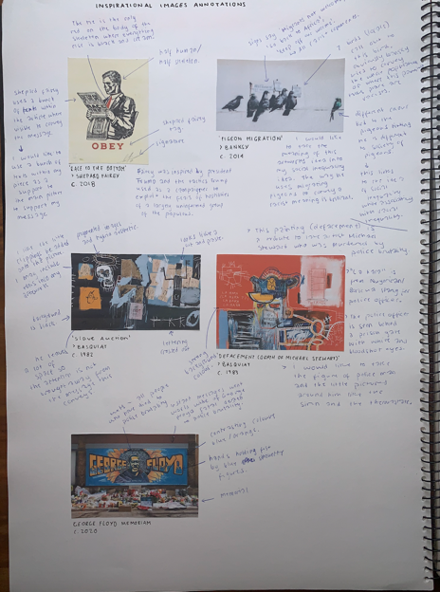 | 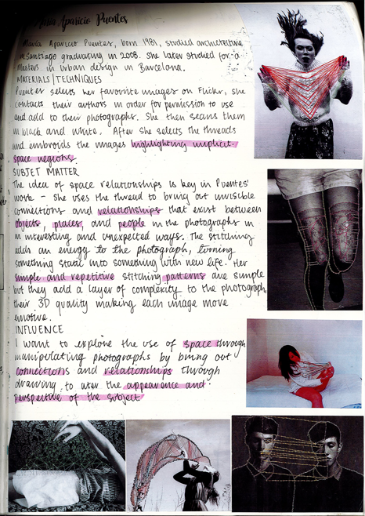 | 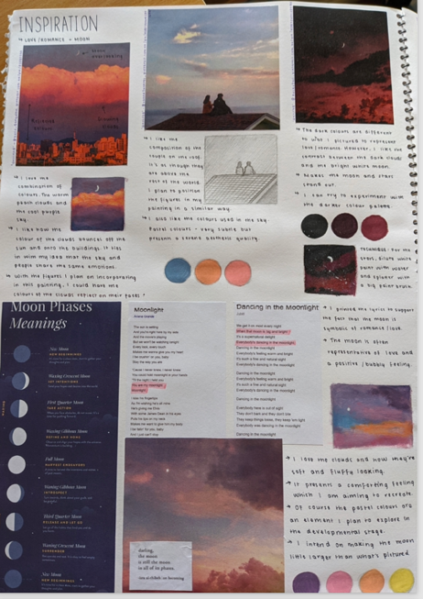

HOW TO ANNOTATE YOUR OWN ARTMAKING PROCESSES

- Describe (what)  -what is this trial of?  -what have you done here?  -what was this stage of the project for?  •2- Explain (how)  -how was this work made?  -what techniques did you use to produce particular effects?  -how did you decide on the composition?  •3- Reflect (why)  -why did you use these specific methods?  -why do particular art elements or principles work better than others?  -what might you do differently next time? | 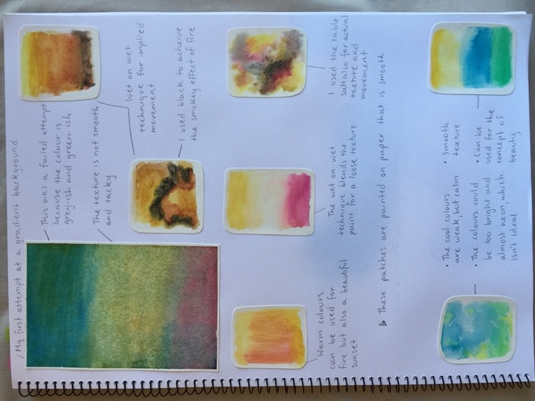

ANNOTATION SENTENCE STARTERS FOR TRIALS
- I am using the medium of __________________. I am finding it ____________ because _______________.
- I have use the material ____________. I find this Easy/difficult [choose one] to use because _______________
- This was created using ____________.
- At this stage of using the medium ___________, I created the effect of _________by ________.
- In order to create this effect I __________ with the medium of ______________.
- I used the medium _________. It was successful since.
- I am happy with this drawing because _________________.
- In my next drawing/trial I will try to ______________and _______________.

- I have been trialling the technique of _________________. I am finding it difficult because _________. This means I have had to try _______________.
- This drawing of ____________ .
- The colours of this are successful/ unsuccessful since_______________
- I would like to explore the use of ______ when completing my artwork.
- By adding more/ less , paint/ water it has created _______ affect.

TALKING ABOUT ART ELEMENTS IN YOUR ARTWORK CREATED:

(How are line, colour, shape, tone, form and texture seen in your artwork?)
- The line work I have used is _______________ and ________________. It makes the artwork appear _______________________.
- The _________________- and _________________ colours I have used give the work a ______________mood.
- The colour _______________ is symbolic of _____________ and I have used it to make the work feel ___________________.
- A ___________texture can be seen in the artwork making the viewer feel _______________

