ADJECTIVES TO DESCRIBE AESTHETIC QUALITIES AND ART ELEMENTS

List of Aesthetic Qualities/ Moods/ Feelings
- Calm, content, peaceful, relaxed, tranquil
- Cheerful, happy, joyful, romantic
- Depressed, gloomy, miserable, sad, somber, tearful, unhappy
- Aggressive, angry, chilling, dark, distressing, frightening, violent
- Energetic, exciting, stimulating, thought-provoking
- Boring, dull, lifeless, insipid

Words to describe the composition (the overall set up of the artwork):
- Arrangement, layout, structure, position
- Landscape format, portrait format, square format, circular, triangular
- Horizontal, vertical, diagonal, angled
- Foreground, background, middle ground
- Centered, asymmetrical, symmetrical, balanced, unbalanced, lopsided, off-center
- Overlapping, cluttered, chaotic
- Separate, spacious, empty
- Free, flowing, fragmented
- Formal, rigid, upright, confined
- Negative space, positive space
COLOUR:
- Natural, clear, compatible, distinctive, lively, stimulating, subtle, sympathetic
- Artificial, clashing, depressing, discordant, garish, gaudy, jarring, unfriendly, violent
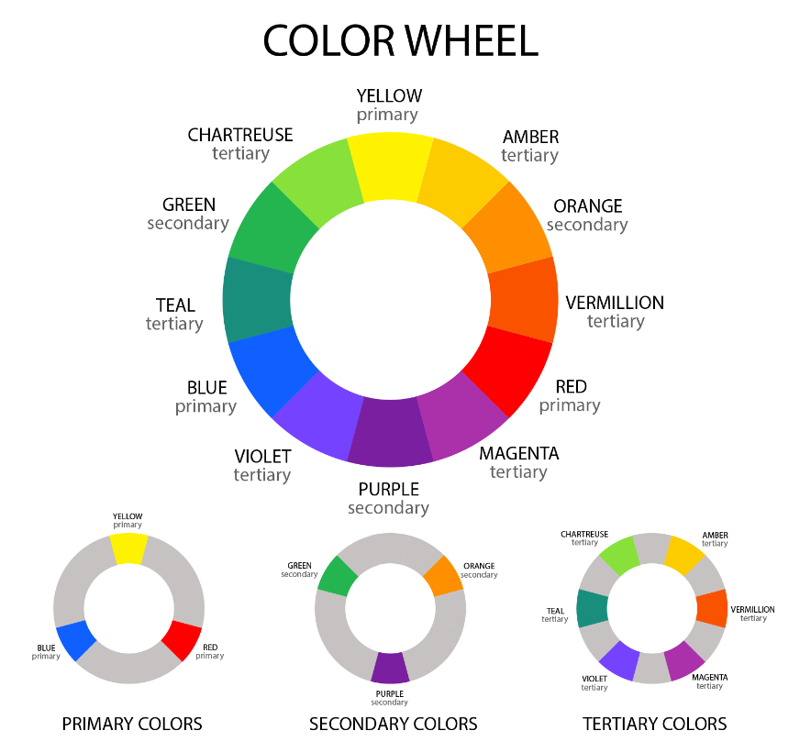
- Bright, brilliant, deep, earthy, harmonious, intense, rich, saturated, strong, vibrant, vivid
- Dull, flat, insipid, pale, mellow, muted, subdued, quiet, weak
- Cool, cold, warm, hot, light, dark
- Blended, broken, mixed, muddled, muddied, pure
- Complementary, contrasting, harmonious

Tone:
- Dark, light, mid (middle)
- Flat, uniform, unvarying, smooth, plain
- Varied, broken
- Constant, changing
- Graduated, contrasting
- Monochromatic
Texture:
- Flat, polished, smooth
- Raised, rough, coarse
- Cut, incised, pitted, scratched, uneven
- Hairy, sticky
- Soft, hard
- Shiny, glossy, reflective
- Semigloss, satin, silk, frosted, matte
Line:
- Line: Thick, thin
- Bold, timid
- Heavy, light
- Edgy, smooth
- Exhibiting glazes, washes, scumbling, dry brushing, stippling, hatching, splatters
- Layered, flat
- Precise, refined, regular, straight, systematic
- Quick, sketchy, uneven, irregular, vigorous
- Regular, patterned
- Exhibiting marks made with a knife, brush
Shape:
- 2-D, flat, abstracted, simplified, stylized
- Sharp, detailed
- Blurred, obscured, overlapping, indistinct
- Distorted, exaggerated, geometric
- Linear, long, narrow
- Hard-edged, soft-edged
Light:
- Backlit, front lit, side lit, top lit
- Having indirect light, reflected light, no directional light source
- Natural or artificial
- Cool, blue, gray or Warm, yellow, red
- Dim, faint, gentle, gloomy, low, minimal, muted, soft
- Clear, brilliant, bright, glowing, fiery, harsh, intense, sharp

